RCB-6201 High-Performance Octa-Core IoT SoM — MediaTek MT8391
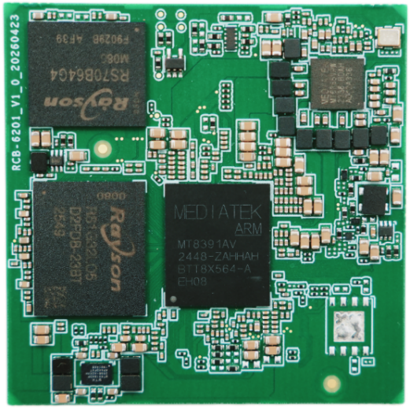
Features
- MT8391（Genio 720）octa-core 64-bit CPU
- Arm Mali-G57 MC2 GPU with Vulkan 1.1 support
- 10 TOPS NPU
- Up to 5K display resolution or dual-screen output
- 4K HEVC video encoding and decoding
- OSM Size-L, 45x45mm

Specifications
Category | Item | Specification
Processor | CPU | MTK MT8391 (Genio 720), 2x Arm Cortex-A78 @ 2.4-2.6GHz, 6x Arm Cortex-A55 @ 2.0GHz
Memory | LPDDR5 | 8GB onboard, optional expansion
Storage | eMMC | 64GB onboard, optional expansion
Display | Display | 2x eDP; 1x MIPI-DSI/LVDS (1x 4-lane MIPI-DSI shared with dual-channel LVDS)
Camera | Camera | 2x 4-lane MIPI CSI
High-Speed Interfaces | USB | 2x USB 3.0 (1x OTG, 1x HOST), 3x USB 2.0
High-Speed Interfaces | PCIe Express | 1x Gen2 x1
Network Interfaces | Ethernet | 1x RGMII
Storage | SDIO | 2x SDIO (1x 4-bit, 1x 8-bit)
General Purpose I/O Interfaces | Connectivity | 2x I2C, 3x SPI, 3x PWM, 16x GPIO
General Purpose I/O Interfaces | UART | 4x UART (including 1x console port)
Power Supply | Input Voltage | DC 12V
Dimensions | Mechanical Dimensions | OSM Size-L 45x45mm
Environmental | Operating Temperature | 0℃ to 60℃ (0% to 90% RH, non-condensing)
Environmental | Storage Temperature | -20℃ to 70℃
Operating System |  | Android 15 / Ubuntu 22.04

Dimensions (OSM Size-L 45*45mm)
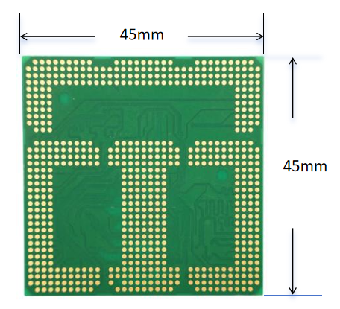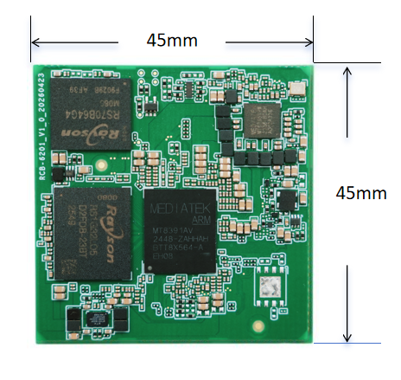

Ordering Information
Product Selection
Model Number | LPDDR5 | eMMC | Operating Temperature
RCB-6201-L01 | 8GB | 64GB | 0°C to 60°C

